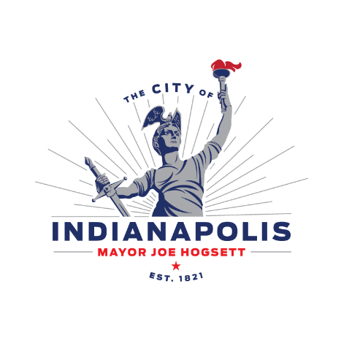
PUBLIC NOTICE OF PLANNED IMPROVEMENT
Burmese American Institute Phase 1B - Sports Courts
Posting Date: 8/14/2025
The City of Indianapolis Department of Public Works (200 E. Washington Street, Suite 2422G, Indianapolis, IN 46225) is submitting a Notice of Intent to the Indiana Department of Environmental Management of our intent to comply with the requirements of the Construction Stormwater General Permit (CGSP) to discharge storm water from construction activities associated with the Burmese American Institute Phase 1B - Sports Courts. The project site will be received by the Haueisen Ditch.
Estimated time of construction will be from September of 2025 to December of 2025. Please direct questions to Elaisa Vahnie at (317) 731-5537 or by email at evahnie@thebaci.org. You can also contact Harrison Rice, Public Information Officer, Department of Public Works – City of Indianapolis at Harrison.Rice@indy.gov.

