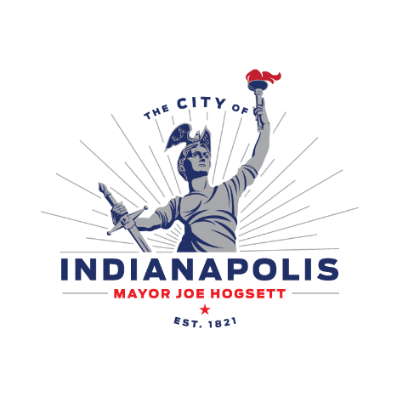
PUBLIC NOTICE OF PLANNED IMPROVEMENT
Garfield Park Improvements
Posting Date: 7/8/2025
The City of Indianapolis Department of Parks and Recreations (200 E. Washington Street, Suite 2422G, Indianapolis, IN 46225) is submitting a Notice of Intent to the Indiana Department of Environmental Management of our intent to comply with the requirements of the Construction Stormwater General Permit (CGSP) to discharge storm water from construction activities associated with the Garfield Park Improvements. Drainage from the project site will be received by Bean Creek.
Estimated time of construction will be from October 2025 to August of 2026. Please direct questions to VS Engineering at 317-613-9917 or by email at jvangampler@vsengineering.com. Harrison Rice, Public Information Officer, Department of Public Works – City of Indianapolis at Harrison.Rice@indy.gov.

