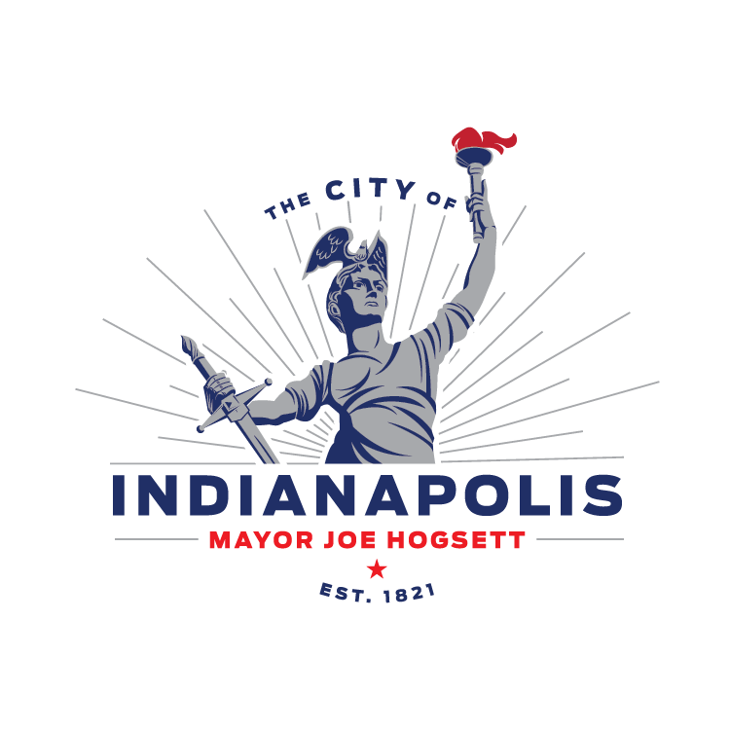Click here to enter a date.

Click here to enter text.

Click here to enter text.

Click here to enter text.

Click here to enter text.

**Subject: Notice of Approved Work Plan and Notice to Proceed (NTP) for Proposed Improvement DPW Project No.** Click here to enter text.

Dear Click here to enter text. :

In accordance with Chapter 645 – Article VII of the Municipal Code of the Consolidated City and County Indianapolis/Marion, Indiana, this letter serves as your notice that your work plan was approved for the proposed project No. Click here to enter text.. Attached is copy of the approved signed work plan for your records.

We are providing the following:

1. Project name: Click here to enter text.

2. Geographical limits: Click here to enter text.

3. General description of work: Click here to enter text.

4. Project bid date: Click here to enter text.

5. Name of Project Designer & contact information: Click here to enter text.

6. Name of DPW Project Manager & contact information: Click here to enter text.

This letter will also serve as your notice to proceed with your work under project number Click here to enter text. as outlined in your approved work plan dated Click here to enter a date.

You are reminded that it is your work crew’s responsibility to:

1. Obtaining and activating proper permits through the Department of Business and Neighborhood Services, Right-of-Way (ROW) Division. When completing your ROW permit application, please be sure to complete the applicable areas regarding the DPW project. Permit fees are waived for DPW projects.
2. Establish and maintain temporary traffic control while on City right-of-way in accordance with the Indiana Manual on Uniform Traffic Control Devices for Streets and Highways (MUTCD).
3. Have an erosion and sediment control plan. A Rule 5 permit must be obtained from IDEM if more than 1 acre (cumulative) of soil is to be disturbed by your relocation.
4. Perform all relocation work within City right-of-way in accordance with the City of Indianapolis Regulations for Activities within Public Right-of-Way.
5. Clear the right-of-way for utility activities.
6. Relocate your facilities and not impede the City’s contractors’ progress for the project.

You are required to contact Click here to enter text., DPW Project Manager and Click here to enter text. DPW Resident Project Representative (RPR) prior to beginning any work in the City right-of-way including delivery of materials, placement of equipment or beginning construction. Please send a copy of all correspondence to:

1. Click here to enter text., DPW Design Project Manager; email: Click here to enter text.
2. Click here to enter text., DPW Construction Project Manager; email: Click here to enter text.
3. Click here to enter text., DPW Project Design Consultant Utility Coordinator; email: Click here to enter text.
4. Click here to enter text. , DPW Resident Project Representative; email: Click here to enter text.
5. DPW Utility Coordination Email: [UtilityCoordination@indy.gov](mailto:UtilityCoordination@indy.gov)

Sincerely,

Click here to enter text. Click here to enter text.

DPW Design Project Manager DPW Project Design Consultant Utility Coordinator