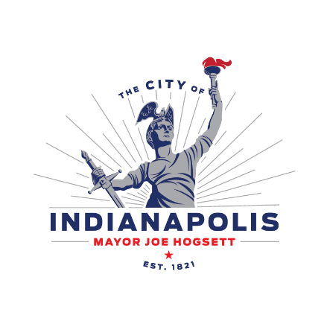
FOR IMMEDIATE RELEASE
October 7, 2024
INDY DPW ANNOUNCES 2024 LEAF COLLECTION SEASON
INDIANAPOLIS —Today, The Indianapolis Department of Public Works (Indy DPW) announced this year's leaf collection will run from Monday, Nov. 11 to Friday, Dec. 6, 2024. Residents can leave up to 40 bags of leaves for pick-up per week on their regularly scheduled collection day during the four-week collection period at no additional cost. During the week of Thanksgiving, leaf collection will be operating on a slide schedule.
Indy DPW collects thousands of tons of leaves each year from Marion County residents. Leaf collection dates coincide with the time of year when the most leaves are determined to fall from trees.
Here are a few guidelines to follow during leaf collection season:
- Place leaves in plastic bags. Paper bags can deteriorate and break apart in inclement weather.
- Keep bags at least three feet away from your trash cart for easy pickup.
- Leaf bags should be outside by 7 a.m. on your normal trash day.
Indy DPW utilizes many community partners to facilitate a successful leaf collection season.
As in years past, the collected leaves will be taken to the South Side Landfill. The South Side Landfill will not offer composting this year. Residents can also bring their leaves to GreenCycle. GreenCycle administers a $20 fee to drop-off leaves, and they will be composted; however, GreenCycle does not accept plastic bags. Mowing the leaves in your lawn is a great resource for mulch.
While raking leaves, Indy DPW asks that residents clear leaves from storm drain inlets to prevent drainage and flooding problems. Residents should not rake leaves into the streets; this will cause issues with Indy DPW Operations street sweepers. Residents should also remember that burning leaves is illegal in Marion County as it releases harmful particles into the air.
Outside of the four-week leaf collection season, residents can place bags of leaves inside their trash cart or take them to the Citizens' Transfer Station on Saturdays. If crews miss a route for leaf collection service, residents should follow the same procedure as a missed trash pick-up. Residents can open a service request via RequestIndy or by calling the Mayor’s Action Center at 317-327-4622.
For more information, please visit indy.gov/activity/leaf-collection-season.

###

Media Contact:
DPW Public Information Office
DPW.Communications@indy.gov
317-327-8895

